# **CHAPTER I:**

# 

# **INTRODUCTION**

## **INTRODUCTION**

Industrial gases are gaseous materials that are manufactured for use in Industry. The principal gases provided are nitrogen, oxygen, carbon dioxide, argon, hydrogen, helium and acetylene: although a huge variety of gases and mixtures are available in gas cylinders. The industry producing these gases is known as the industrial gases industry, which is seen as also encompassing the supply of equipment and technology to produce and use the gases.

Industrial gases are used in a wide range of industries, which include oil and gas, petrochemicals, chemicals, power, mining, steelmaking, metals, environmental protection, medicine, pharmaceuticals, biotechnology, food, water, fertilizers, nuclear power, electronics and aerospace. Industrial gas is sold to other industrial enterprises; typically comprising large orders to corporate industrial clients, covering a size range from building a process facility or pipeline down to cylinder gas supply. In Malaysia, GAS often used in homes and shop to. This energy source is usually supplied using gas cylinders, which limits the practicality of its usage.

GET GAS POS System for Gas Distributors Company is one of interactive web-based applications and mobile friendly. This system is specifically built for retail industry since it relatable with demand and supply of products. A systematic and effective application is compulsory since this will the company management to make a right decision and drawn a meaning conclusion on their monthly report. Manual and human works sometimes produce an error that difficult to identify.

There must be an improvement on their summary report since moving forward recorded data will insight a significant information to their company compete with other competitors. To ensure they record and track all data/information, an effective and system application is needed to reduce any error and circumstances.

Systematic system will allow user to manage their supply and demand in a smooth way. Hence, company will face less problem and give high profit. Finally, their growth of business will become more stable.

## **PROBLEM STATEMENTS**

There are many problems occur on the existing system, particularly in the access system management. Difficulty accessing data at a maximum level is often happens because of the data on paper and only be in one place only. Due to the inefficient access system management, there are some problems occur such as:

1. Awareness of systematic and structural on data management in Retail SME company

Before this, not easy to get the systematic and structural data in manually. When it be manual, so it can give problem for Gas Distributor Company.

1. Awareness for company keep report for them in manually.

The circumstances an occur from the previous apps is enabling to abstract historical data for checking performance. Company may face a problem to monitoring and doing them owns internal and external bench marking.

1. To reduce human error in calculating final cost.

Previously, cost and to get final cost are manually calculated and recorded. When it comes to manual human error calculating will wrongly calculate and company will face loss.

## **1.3 AIM**

To develop web application to be used named “GET GAS POS System for Gas Distributors Company”.

## **OBJECTIVE**

The objectives of this project are:

* To design and build comprehensive Point of Sale (POS) system for Gas Distributor Company (Retail SME)
* To record and track client’s sales and buyer information.
* To automate cost calculation and produce stock report, sales report, buyer summary report

## **SCOPE OF PROJECT**

The scope for this system is divided into two categories which are system scope and user scope. The system scope explains about the functionality of what the system can do while the user scope is about the type of user and their tasks.

**1.5.1 Scope of user**

The users are divided into three categories which are security admin, manager and staff.

**1.5.1.1 Admin**

1. Admin can register employee which is manager and staff in application.
2. Admin can view the stock of gas cylinder.
3. Admin can manage a stock which is add stock.
4. Admin can manage customer. Which is add, update, delete customer.
5. Admin can manage supplier which is add supplier.
6. Admin can view the people which is customer and supplier.
7. Admin can view the sales report.
8. Admin can view detail info for customer and supplier.
9. Admin can set product price.
10. Admin can add, update, delete the transaction.
11. Admin can update the payment and view payment status.
12. Admin can manage the report.
    * + 1. **Manager**
13. Manager can manage customer which is add, update customer.
14. Manager can manage supplier which is add supplier.
15. Manager can view the people which is customer and supplier.
16. Manager can view detail info for customer and supplier.
17. Manager can add, update the transaction.
18. Manager can update the payment and view payment status.
19. Manager can manage a stock which is add stock.
20. Manager can manage report.
    * + 1. **Staff**
21. Staff have to login with their own Employee ID.
22. Staff also can manage a stock which is add stock.
23. Staff can manage customer which is add and update customer.
24. Staff can manage supplier which is add and update supplier.
25. Staff can view the people which is customer and supplier.
26. Staff can add, update the transaction.
27. Staff can update the payment and view payment status based on login ID with their own record.
28. Staff can view and print the payment for their own record.
    * 1. **Scope of system**

The system scope is divided into five modules which are registration module, stock module, people module, transaction module and report module for web based and mobile application.

* + - 1. **Registration module**

1. Admin register employee to use the application.
2. Manager should log in to start the application with their Employee ID
3. Staff should log in to start the application with their Employee ID.
   * + 1. **Stock module**
4. admin can view the stock.
5. Manager can view the stock.
6. Staff can view the stock.
7. Admin set product price.
8. Admin can delete product.
9. Admin can add product.
10. Store current stock of gas cylinder which is filled or empty.
11. Check amount stock out.
    * + 1. **People module**
12. Admin, manager and staff can manage new people or new sales person in application.
13. For delete only admin can delete people in application.
14. People divided for two, customer and supplier.
15. Customer buy the gas cylinder.
16. Supplier can supply their gas cylinder.
    * + 1. **Payment module**
17. Admin, manager and staff can add, update and delete the transaction.
18. Staff can add and update the transaction with their own record based their ID.
19. Firstly, add the transaction.
20. Choose or add customer.
21. Next, choose the type of gas which is 14kg or 12kg.
22. Set the price.
23. Select the quantity how many gas customers want.
24. Checkout the transaction. They can choose debit or cash to payment
25. After that, if any problem they can update the payment and delete the transaction.
26. Lastly, view the payment status.
    * + 1. **Report module**
27. Admin can view the detail by sales person or monthly record the gas cylinder.
28. Admin can view the summary of payment.
29. Admin view the current stock and previous stock.
30. Admin can view detail info for customer and supplier.
31. Manager also can manage and view the report.
32. Manager can view detail info for customer and supplier.
33. Staff only can view and print the payment for their own report based their ID.
    1. **EXPECTED PRODUCT**

First expected product is to arrange order gas cylinder for customer in the systematic mechanism. This system provides the systematic ordering for customer to help them buy the gas cylinder with more systematic. Next, to monitor supply-demand of stock. This system can monitor or manage stock in and out. Such as, how many full empty gases out and how many empty gases in. It can help company to get the right record about supply-demand of stock. Third, to calculate cost and quantity of full remaining cylinder and empty cylinder. This system will help company to calculate the final cost and profit. Besides that, this system also can help to calculate the quantity of full gas cylinder and empty gas cylinder. Lastly, to integrate systematic summary report on monthly basis to owner. This system will help to produce a report from the various of information. Data collected will be presented in the data form and will help the user to better understand.

* 1. **CONCLUSION**

At the end of the project, the developer needs to achieve the objectives that have been list out in the objectives section in this proposal. There are to develop a database to store the stock of gas cylinder and customers information to manage data systematically. This system should be developed in more systematic way to make user easy to use so that any problems occur can be avoided. Throughout this database driven, the information can be retrieved by any authorized user and in chapter II, the existing system has been described. Developer have given the complete elaboration of the proposed system in chapter III. Conclusion is written in chapter IV and then references, and appendices are attached.

# **CHAPTER II:**

# **LITERATURE REVIEW**

## **INTRODUCTION**

This chapter will cover the literature review which is related with GET GAS POS System for Gas Distributors Company. The purpose literature review is to give summary of facts and findings during develop this project. The activities can be done by studying the academic writing, such as thesis, journal, dissertation and article. This review will give better more knowledge and understanding would give more idea to designing and good methodology suitable for this project. Besides, early preparation can be planning to avoid system failure risk.

* 1. **OVERVIEW OF SYSTEM**
     1. **WEB-BASED APPLICATION**

A web-based application is any application that uses a website as the interface or front-end. Users can easily access the application from any computer connected to the Internet using a standard browser. This contrasts with traditional desktop applications, which are installed on a local computer. For example, most of us are familiar with Microsoft Word, a common word-processing application that is a desktop application. Web application has their advantage for user to use such as easier to develop, more useful for user, easier to install, maintain and keep secure. (Wright, 2018)

* + 1. **WHAT IS POINT OF SALE (POS)**

The term Point of Sale (POS) can be defined as the exchangeable of goods or services by providing customer payment information through technology devices. This technology was built on 1879 mechanical till to electrical form was generated in the mid-70s. Personal Computing (PC) mechanism was fully implemented on POS in the 1980s. Scanning of barcode and payment card becoming other functions for POS. Check-out counter at retail or grocery store are the current example on the use of POS system. However, different business type will used different form of POS based on their culture of business (Bryner, 2012).

The current POS system may have a lot of similarities with previous system (traditional system). However, stakeholder is one of major difference between POS with the other system. POS's stakeholders can divide into 9 which are; Consumers, Merchants, Acquirer, Issuer, Card Brand Companies, Payment processor, Payment gateways, Software vendors, Hardware vendors. The main group for Consumer are people that use payment card in ordering goods or requiring services. Meanwhile, Merchants are the group of people that processing the consumer purchases through payment card that act as payment for their good purchases. They are also the main user in POS (Bryner, 2012)

* 1. **MOBILE APPLICATION FOR GAS DISTRIBUTORS COMPANY RESOURCES.**

Android retail is a system that manage the apps of mobile which ease to use and portability make it become important to business environment user even though cost of implementation is high. Work scope of cashier becomes more systematic and effective by using Mobile apps as compared with to traditional POS system. This is because smartphone and tablet technology are the main devices that have been used by this apps which are more realistic with current daily activities. (TheAppSolution, 2018)

* + 1. **CASE STUDY**

**2.3.1.1 The Retail App**



Figure 2.1: Homepage of the Retail App.

The Retail App is one of application that mainly used in android user environment. The application is selling all product, such as clothes for male and female in various kind of fashion and product for female. The store has two different methods which are online and in-app store. This application also provides a blog to ensure customers are up-to-date on their latest fashion and promotions.

Strengths for The Retail App is personalized coupons. Brick-and-mortar retailers can make their app a must-have by delivering personalized coupons. Because mobile devices contain a wealth of data about their owners, retailers can gain valuable insight into customer’s shopping history and make offers that are tailored to them. This can drive quick conversions and lower drop-off rates. Customers will appreciate that the app not only enables them to save money, but also treats them as a valued customer. Personalized coupons are also a way for retailers to build a sense of community. Apps are interactive, and this allows retailers to create loyalty programs that are multidimensional. Lastly, the weakness for The Retail App is all product with same and all pricing changes occur at the same rate. In most cases, this is not realistic in retail because of the many variations that exist in merchandise pricing (Infusion121, 2017)

* + - 1. **Retail Pro**

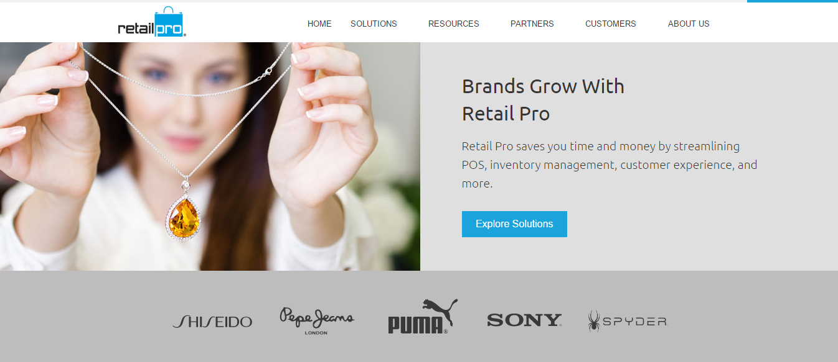

Figure 2.2: Homepage of Retail Pro web based.

Retail pro already use by 54000 stores within 125 countries and classified as popular global post software. Based on their 25years experience in POS industry, their customer’s loyalty not only comes from small taller but also in big name retailer such as Calvin Klein, Adidas and La Perla. The software became the most suggested software from customer review since it has good features mainly focusing in inventory customer and employee management function. It the software build to help the efficiency in client business specially in retail industry. (Retail Pro Software Solutions | Your global retail software partner, 2017)

Features of Retail Pro have minimum requirement to access their system. Which is, Minimum for window is window 7 (32-bit). After that, Retail Pro just support Core i3 and above for access with their system. The desktop or laptop need have 4GB memory and 7200 RPM for hard drive.

Knowing the strengths and weaknesses gives user a better understanding of system and how its function. Understanding the strengths keeps user ahead in a lot of things. So, Retail Pro also have their strengths and weakness. For strengths, Retail Pro can integrations and Add-Ons. Such as, Sage accounting application MAS 90, Business Works, QuickBooks and Microsoft Dynamic GP: Accounting. Lastly for weakness, Retail Pro not having ability to edit the preloaded report formats to suit the business need and not suitable with service related business.

* + - 1. **Hawker POS**

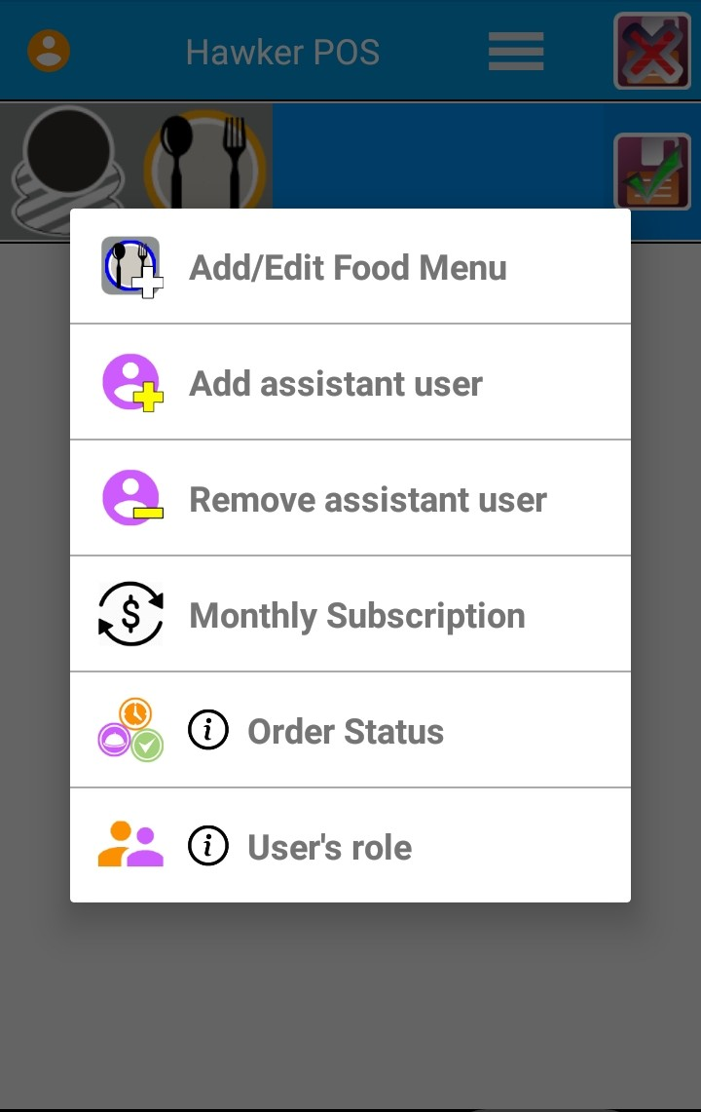

Figure 2.3: Homepage of Hawker POS

Hawker is a mobile application only for android. This application is focusing on food business marketing such as ordering food processes. There are several functions available for example editing and adding menu mainly used by admin. Order status is applicable in this application and it has 3 different function such as food preparation, food delivery and cash on delivery. Hawker POS has special function to maintain customer loyalty is through monthly subscription with special offer. Hawker is a mobile application only for android. This application is focusing on food business marketing such as ordering food processes. There are several functions available for example editing and adding menu mainly used by admin. The strengths for this application is easy to use for user and friendly for used. Hawker POS also have disadvantage. The weakness is seamless checkout. The final feature the Hawker POS app is missing is this system only can used in mobile not for desktop or laptop (Ezysoftsolution, 2018)

* + - 1. **ShopKeep**



Figure 2.4: Homepage of ShopKeep

ShopKeep is designed in simple and elegant concept. The main function is focusing on small businesses relating on food and beverage catering. Utilization on hybrid setup is implemented on this software. The software only can be run in IOS environments and the data will be sync’ing back the cloud under internet connection. ShopKeep more suitable used on IOS 7 and supported by Ipad. ShopKeep has an online shop with all the hardware that works with the software. The strengths of ShopKeep is good and suitable for small and medium business. Besides that, this system also well-designed for use in foodservice application for user and also have integration and Add-ons such as MailChimp, QuickBooks online, AppCard. AppCard is a “integrate loyalty program that provides personalized offer, impressive reporting, and syncs with your ShopKeep sales data”. Lastly, compatible credit card precessors. For Weakness is ShopKeep only can run exclusively on IOS 7 and the ipad mini. For above IOS this application cannot run and the Ipad register can only host up to 270 buttons if it number higher, it can be rung up by barcode scanner or manual (Ibrahim Khalil, 2017)

* + - 1. **Vend**

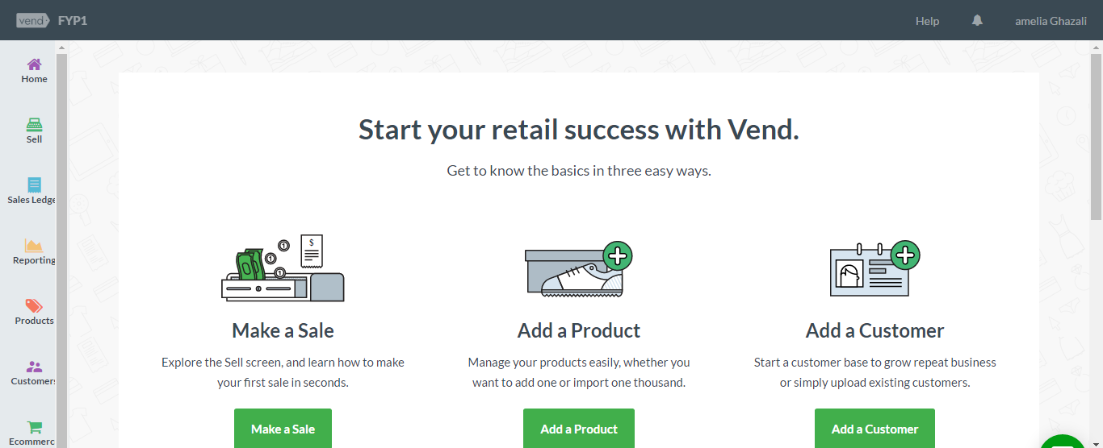

Figure 2.5: Homepage of Vend in web based

Vend is a cloud-based point of sale system for retailers of all types and sizes. There are several functions that has been offered by vend. Such as customer experiences, management, sells and inventory, and more. (softwareadvice.com,2017). liability in any devices make it became and intuitive apps. Easy to use one of its specialty since customer happiness is their direction. It interfaces also looks standard of professional. Android and IOS smoothly work with this app. Vend has important function which is worked offline. This will allow selling process to continue occur without internet connectivity. Other function implemented in this app is New function in Vend apps is customers can check into your store on their mobile phone and pay using their PayPal account. Strengths for Vend is available on both web and mobile devices. Besides that, vend also can control users’ access and can add additional data field in system. User can used Vend in online and in offline, lastly, this system offers multi-store function. For weakness is Vend not suitable with service related with a business and the big problem in Vend is graphic user interface cannot be customized (Vend - Point of sale you'll love to use., 2014)

**2.3.1.6 Case Study Comparison**

Table 2.1 shows the main features of the existing applications for Point of sales application (The Retail App on the App Store, 2017; Hawker POS- Android Apps on Google Play, 2017; Vend - Android Apps on Google Play, 2017; ShopKeep- Android Apps on Google Play, 2016; Last Retail Pro - Android Apps on Google Play, 2015).

Table 2.1: Comparison of features among the existing application for Point of sales application.

|  |  |  |  |  |  |  |
| --- | --- | --- | --- | --- | --- | --- |
| **FEATURES** | | Vend | The Retail app | ShopKeep | Hawker POS | Retail Pro |
| **FUNCTIONALITY** | Inventory Management | √ | √ |  |  |  |
| Customer Management |  | √ |  |  | × |
| Reporting | × | × |  |  |  |
| Accounting Management |  | √ |  |  |  |
| **POS FEATURES** | Barcode Scanning | × | × | × | × | × |
| Coupon |  | × | × |  | × |
| Credit Card Processing | × | √ |  |  |  |
| Customer History |  | √ | × |  | × |
| Discount | × | √ |  |  |  |
| Gift Cards |  | √ |  | × |  |
| Mobile POS Capability |  | √ |  |  |  |
| Multiply payment Forms |  | × | × |  |  |
| Print Receipts |  | √ |  |  |  |
| Refunds |  | √ |  |  |  |
| Sales Commissions | × | × | × | × | × |
| **REPORTING FEATURES** | Daily Closing Report | × | × |  |  |  |
| Graphical Report |  | √ | × | × | × |
| Inventory Report |  | × |  |  | × |
| Item Performance  Report |  | × | × |  | × |
| Sales Report |  | √ |  |  | × |
| **MANAGEMENT FEATURES** | Customizable Data  Fields |  | √ |  |  | × |
| Inventory  Classification |  | √ | × |  | × |
| Inventory Reorder Alert |  | × | × | × |  |
| Multiple Stores |  | × |  | × | × |
| **CUSTOMER MANAGEMENT FEATURES** | Customer Comments | × | √ | × |  | × |
| Customer Information |  | × | × |  | × |
| Printing | × | × | × | × | × |
| Purchase History |  | √ |  |  |  |
| Sales Person History |  | √ |  |  |  |
| **RETAIL**  **ACCOUNTING FEATURES** | Account Payable | × | × | × |  | × |
| Account Receivable |  | √ |  |  |  |
| Purchase Orders |  | √ |  |  | × |
| Sales Audit |  | × | × | × | × |

* 1. **SUMMARY**

This chapter presents investigations on Point of sales for Gas Distributors Company. A good understanding of the related issues is important to develop an interactive application for GET GAS POS System for Gas Distributors Company. From the case study on applications, almost all application required in Point of Sales system include in application. But, some of application also don’t have a systematic report about stock, product and customer information. Therefore, GET GAS POS System for Gas Distributors Company will consider on all requirement of this project especially about systematic report during the development of the application

# **CHAPTER III:**

# **RESEARCH METHODOLOGY**

**3.1 INTRODUCTION**

Research methodology is a systematic way to solve a problem. This chapter covers the description on development methodology that is used in this project. Many methodologies outside there such as Agile, Waterfall, System Development Life Cycle (SDLC) and Extreme Programming (EP) are useful in developing a system and it is depending on someone who want to work with. In this project, the methodology is Rapid Application Development (RAD). The method is using to achieve the objectives of the project that will accomplish a correct result. Generally, Rapid application development typically involves the following basic steps that complete the process, the step is Planning, Design, Construction and Cutover.

**3.2 PROJECT METHODOLOGY**

This project used four major steps to implement project starting from database initial study until the evaluation. All the methods used for finding and analyzing data regarding the project related. The cycle of RAD model phases is shown in Figure 3.1

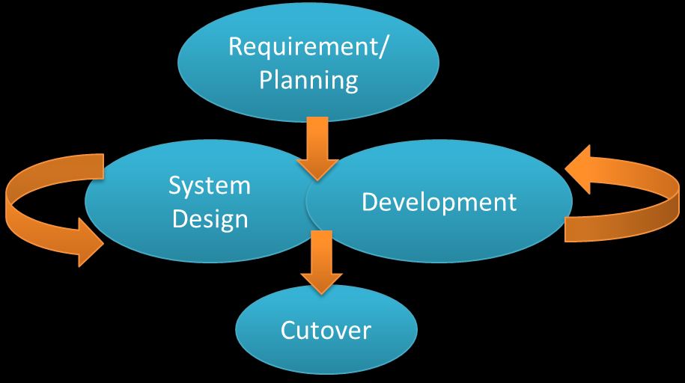

Figure 3.1: Rapid Application Development (RAD)

**3.2.1 Requirement Planning Phase.**

The first step allow study conducted to determine about the function of this project should be. In this phase, the requirement will develop the GET GAS POS System for Gas Distributors Company, include the function of the software to be developed based on the program’s constraints and the goal of the project. All the requirement is gathered from the client and will be analyze. Means, after admin, manager and staff agree and discuss with all business needs, project scope and all system requirement, so it ends when the team agrees on the key issues and obtains management authorization to continue.

Requirement planning phase it covers the activity of GET GAS POS System for Gas Distributors Company. So, for this phase developer need to understand the domain area, process involves and what kind requirement needed to develop system. So, after decided with client we are using two technique for gathering the requirement which are document review and semi-structured document. For my project, I get document from my supervisor which are my client Dr. Munaisyah Binti Abdullah. I get real document from company about their customer, and stock. Besides that, I also get document which is report last semester about this company to help me understand about this project. During the interview about the process and implementation for the GET GAS POS System for Gas Distributors Company. This technique is being applying for a several times to ensure other requirement such as the statement of problems, aim, objectives and scope.

**3.2.2 Design Phase**

Design is a continuous interactive process that allows users to understand, modify, and eventually approve a working model of the system that meets their needs. In this phase, all the UML diagram will be create including the Use Case Diagram, Sequence Diagram, Class Diagram and Entity Relationship Diagram. The interface of the system also is created based on the requirements and all the coding is made to ensure the system can function very well without have any error. This step is repeated as often as necessary as the project evolves.

Design is the process to visualize flow of data for this system. So, developer need to design alternative solution to give explanation of the system flow. For this project, developer need to design a use case and class diagram to give explanation about the system. Lastly, the developer also designs the interfaces of web-based application using paper interface. Before to develop web-based system, developer need to sketch the interface first to get the good interface.

**3.2.3 Development Phase**

Focuses on program and applications development task like SDLC. In this phase, the users will continue to participate, and they can still suggest whatever changes or improvement as actual screens or reports.

In this development phase, developer need to know what language used for developing the system such as java, php, angular or others language. Beside that, developer also need to know what database used such as MySQl, MySQLi and etc. After that, developer will start creating a system with right requirement from client.

**3.2.4 Cutover Phase**

The final stage will resemble in the SDLC implementation phase, including data conversion, testing, and changeover to the new system. In this phase, user can test the system whether it is good or not. The cutover phase is like implementation phase. The cutover or implementation phase involves implementing the new system and managing the change from the old system environment to the new one. This may include implementing bridges between existing and new systems, converting data. User acceptance is the end of the implementation stage.

During cutover phases, the developer performs a web-based and application verification using several testing methods and test case written to ensure the application and web-based delivered to the client in order to achieve client satisfaction. The technique chosen to be applied during the testing are unit testing, application testing and the user acceptance testing

**3.3 PROJECT SCHEDULE**

The research project started in January 2018 and was completed in November 2018. GET GAS POS System for Gas Distributors Company will take 2 semesters to be develop. The development of GET GAS POS System for Gas Distributors Company starting from the Requirement Planning phase until the Cutover phase. Figure 3.2 shows the project schedule of GET GAS POS System for Gas Distributors Company

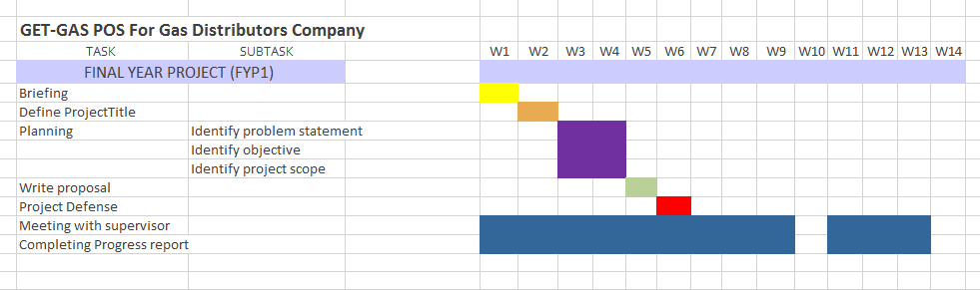

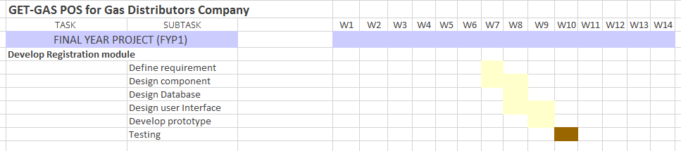

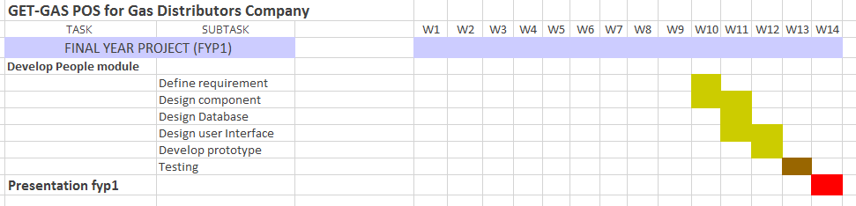

Figure 3.2: Gant Chart for FYP1

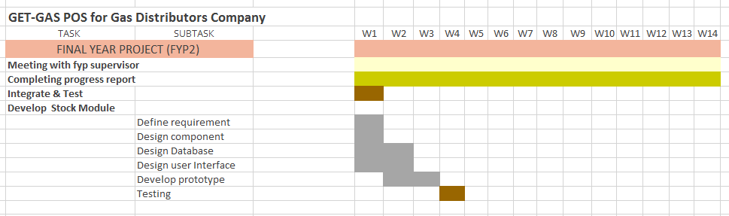

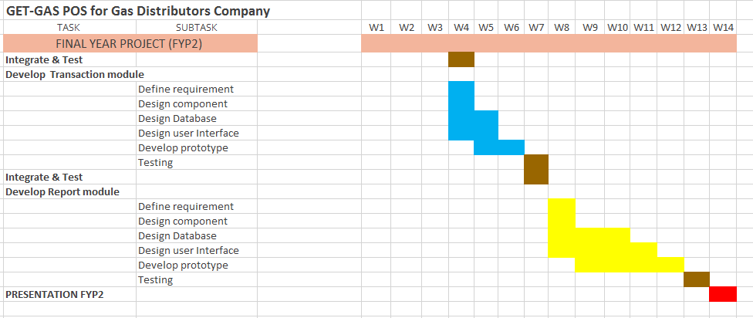

Figure 3.3: Gant Chart for FYP2

**3.4 HARDWARE AND SOFTWARE SPECIFICATION**

Combinations of hardware and software used to develop the system shown in Table 3.1 and Table 3.2.

Table 3.1: Hardware requirements specification

|  |  |
| --- | --- |
| **HARDWARE REQUIREMENT** | |
| **Laptop / Processor** | Asus X452E (Laptop) |
| **Memory** | 8.00 GB |
| **Tools** | HP Printer |

Table 3.2: Software requirements specification

|  |  |
| --- | --- |
| **SOFTWARE REQUIREMENT** | |
| **Programming Language Used** | HTML, JAVA, C#, ASP.NET, CSS, SQL |
| **Develop tools** | Ionic Cordova, Xampp, Notepad++ |
| **Database** | MySQL |
| **System Planning** | Microsoft Project |
| **Reporting** | Microsoft Office 2017(Word, PowerPoint, Excel, Visio) |

**3.5 CONCLUSION**

As a conclusion, every project has a different methodology that is being used to make the project success and working well. This project used Rapid Application Development (RAD) as system development methodology to achieve the objectives of the project that will accomplish a perfect result. This project methodology and planning explains in detail all the RAD stages that are used for this project.

# **CHAPTER VI:**

# **PROTOTYPE/PRODUCT DEVELOPMENT**

**4.1 Introduction**

This chapter will cover all the analytical project prototype and system design for Get Gas POS for Gas Distributors Company. The focus on development process are covers the system requirement, designing the UML diagram and system design. All the activities are important to make Get Gas POS for Gas Distributors Company become complete product.

**4.2 System requirements specification**

The system requirement describes the system function and features that available in the Get Gas POS for Gas Distributors Company. The system requirement consists two type of requirement which are functional requirement and non-functional requirement. The project using the web-based development for human resource interface.

**4.2.1 Functional requirements**

In requirement engineering the functional requirement defines the system functions or its component. The requirement describing all the activities should have in the system to fulfil the business need and user acceptance. Table 4.1 below are the list of functional requirements.

Table 4.1: functional requirement

|  |  |  |
| --- | --- | --- |
| **Function ID.** | **Function Description** | **Risk Level** |
| REQ1 | Login with employee id | High |
| REQ2 | Register employee | High |
| REQ3 | View employee | High |
| REQ4 | Delete employee | High |
| REQ5 | Add people (customer & supplier) | High |
| REQ6 | View people (customer & supplier) | High |
| REQ7 | Delete people (customer & supplier) | High |
| REQ8 | Add stock | High |
| REQ9 | View stock | High |
| REQ10 | Delete stock | High |
| REQ11 | Add payment | High |
| REQ12 | View payment | High |
| REQ13 | Delete payment | High |
| REQ14 | View sales report | High |
| REQ15 | View stock report | High |
| REQ16 | View summary detail report | High |

This section explains about the functional requirements of Get Gas Application, starting with general requirements as in Table 4.1, followed by requirements of each features of the system.

Table 4.1.1: General Requirements

|  |  |
| --- | --- |
| **Requirement ID** | **Description** |
| REQ_G001 | System shall request for input employee ID and password before using this system. |
| REQ_G002 | System shall allow user to logout in this system after using this system. |
| REQ_G003 | System shall be able to verify employee ID and password provided by the user. |

**4.2.1.1 Register Module Requirement**

Table 4.1.2: Register Module Requirement

|  |  |
| --- | --- |
| **Requirement ID** | **Description** |
| REQ_F001 | System shall request for user (admin) to register user which is manager and staff with their own employee ID to using this system. |
| REQ_F002 | System shall allow user to login with their ID and correct password. |

**4.2.1.2 Stock Module Requirement**

Table 4.1.3: Stock ModuleRequirement

|  |  |
| --- | --- |
| **Requirement ID** | **Description** |
| REQ_GS001 | System shall be able to display current stock and new stock |
| REQ_GS002 | System shall be able to update, delete and add new stock provided by user (admin) |

**4.2.1.3 People Module Requirement**

Table 4.1.4: People ModuleRequirement

|  |  |
| --- | --- |
| **Requirement ID** | **Description** |
| REQ_GP001 | System shall be able display information people which is customer and supplier. |
| REQ_GP002 | System shall be able to user add new customer and supplier in this system. |
| REQ_GP003 | System shall allow user to delete new customer or supplier. |
| REQ_GP004 | System shall allow user to update information of customer or supplier. |

**4.2.1.4 Payment Module Requirement**

Table 4.1.5: Payment ModuleRequirement

|  |  |
| --- | --- |
| **Requirement ID** | **Description** |
| REQ_GT001 | System shall request to user add payment in this application. |
| REQ_GT002 | System shall allow user to choose cash or debit for transaction. |

**4.2.1.5 Report Module Requirement**

Table 4.1.6: Report ModuleRequirement

|  |  |
| --- | --- |
| **Requirement ID** | **Description** |
| REQ_GR001 | System shall be able display report. |
| REQ_GR002 | System shall be able display for stock report. |
| REQ_GR003 | System shall be able display for sales report. |
| REQ_GR004 | System shall be able display for summary detail report. |

**4.2.2 Non-Functional**

Non-functional requirement specifies criteria the requirement that are not covered in the functional requirement. It is often known as the quality attributes should have in the system to support the project performance.

Table 4.2.: Non-functional requirement

|  |  |  |
| --- | --- | --- |
| **Requirement ID** | **Requirement Descriptions** | **Type** |
| **REQ 1.1** | The design of the user interface should be simple and easy to understand. | Simplicity |
| **REQ 2.1** | The system should be able to navigate and display the suitable label and help user to read properly. | Usability |
| **REQ 3.1** | The system should be able give the response time in optimal time when the data integrate with the database. | Performance |
| **REQ 4.1** | The system should be able to user in any kind of browser. | Portability |

**4.2.3 Software Requirement**

Table 4.3: Software Requirements

|  |  |
| --- | --- |
| Xampp 3.2.2 | XAMPP is a free and open source cross-platform web server solution stack package developed by Apache Friends, consisting mainly of the Apache HTTP Server, MariaDB database, and interpreters for scripts written in the PHP and Perl programming languages |
| Google Chrome | Google chrome is open source web browser developed by google used to access the web-system. |
| Notepad++ 7.5.6 | Notepad++ is a text editor and source code editor for use with Microsoft Windows. It supports tabbed editing, which allows working with multiple open files in a single window. The project's name comes from the C increment operator. Used to create web-based application using PHP language. |
| Microsoft Windows 8.1 | Operating system platform use throughout the project |
| Microsoft Office 2016 | Use to make documentation for the project |
| Microsoft Project 2016 | Use to make Gantt chart for the project |
| Microsoft Visio 2016 | Use to make some diagram for the project |

**4.2.4 Hardware Requirement**

Table 4.4: Hardware Requirements

|  |  |
| --- | --- |
| **NO** | **HARDWARE REQUIREMENTS** |
| **1** | Asus Laptop (RAM 4GB, Quad Core X4, windows 8.1, HDD 500 GB) |
| **2** | HP Printer |

**4.3 Design**

The system design includes UML diagrams, storyboard and system architecture. The UML diagrams involve use case diagram and sequence diagram. The next section illustrates the design of the applications.

**4.3.1 Use Case Diagram**

All the functions of the system are shown as the use case in table below:

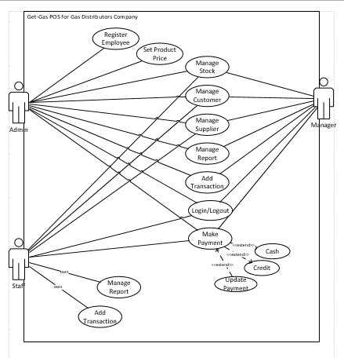

Figure 4.1 Use case diagram for Get-Gas: POS For Gas Distributor Company

**4.3.2 Use Case Specification**

Use case specification explain the details of the functionality of the system and describes how the actor will involve using the system to obtain the actual results. The following Table shows the use case descriptions for this system

Table 4.5: Use Case description for Get Gas POS system for Gas Distributors Company

|  |  |  |
| --- | --- | --- |
| **Use Case ID** | **Use Case Name** | **Description** |
| UC001 | Login | User must enter their employee ID and password to login. |
| UC002 | Register Employee | Admin must register for new user first before they can login to the system. |
| UC003 | Set Product Price | Admin needs to set for each product price in the system. |
| UC004 | Manage Stock | User can edit, add the stock but for delete stock only admin can access. |
| UC005 | Manage Customer | Admin can manage their registered customer in the system but for delete customer only admin can access. |
| UC006 | Manage Supplier | User can manage their supplier but for delete supplier only admin can access. |
| UC007 | Manage Report | User can manage their report, but staff can only manage their own report based on their id. |
| UC008 | Add Transaction | User can update the transaction with their customer. |
| UC09 | Make Payment | User can make the payment. |

### 4.3.2.1 Login



Figure 4.2 Use case for user login

The following table shows the details of figure 4.2:

Table 4.6: Login Use Case Description

|  |  |  |
| --- | --- | --- |
| **Use Case ID** | UC001 | |
| **Name** | Login | |
| **Brief Description** | A registered user for logs into the system | |
| **Actor(s)** | Registered user, administrator | |
| **Flow of Events** | | |
| **Basic Flow** | | |
| This use case starts when the system registered user to the system and need goes to the login page.   1. The system gives the user for the employee ID and password. 2. User needs to enter the employee Id and password before goes into system. 3. The system validates the entered employee ID and password, user need to make sure they enter a create employee ID and correct password. 4. User signed in the system and return to the dashboard page. 5. The use case end. | | |
| **Alternate Flows** | | |
| **Title** | | **Description** |
| User Fails Authentication | | If user entered invalid employee ID and password, the following occurs:   1. System give reason why user failed to login. 2. The system prompts user to enter the invalid employee ID and password. |
| **Pre-Conditions** | | |
| **Title** | | **Description** |
| (None) | | User is not logged the system. |
| **Post-Conditions** | | |
| **Title** | | **Description** |
| Success | | The user is authenticated, and the system display a dashboard page. |
| Failed | | User is unable to log in for one or more reasons |

### Register Employee



Figure 4.3 Use case for user register

The following table shows the details of figure 4.3:

Table 4.7: User Register Use Case Description

|  |  |  |
| --- | --- | --- |
| **Use Case ID** | UC002 | |
| **Name** | Register Employee | |
| **Brief Description** | User (admin) can register new user (staff & manager) into system | |
| **Actor(s)** | Admin | |
| **Flow of Events** | | |
| **Basic Flow** | | |
| This use case starts when the admin is register new user to logged into system.   1. The system prompts the user for the employee ID and password. 2. The system prompts user to input new user registration information: Employee ID, Password, Email Address, Name, Contact number. 3. The user enters and input the information. 4. System verifies and create new account. 5. The use case ends. | | |
| **Alternate Flows** | | |
| **Title** | | **Description** |
| 3a. Cancel Registration | | 1. User click cancel registration and back to dashboard page. 2. The system returns the user to dashboard page without save any information in database. |
| 3b. Invalid information Entered | | 1. User click submit after input and enter information to system. 2. The system display information with appropriate message to correct invalid information. 3. User re-enter information. |
| **Pre-Conditions** | | |
| **Title** | | **Description** |
| (None) | | User is not registered into the system |
| **Post-Conditions** | | |
| **Title** | | **Description** |
| Success | | The new user can access the system with their employee ID and correct password. |
| Failed | | User is unable to log in for one or more reason. |

### 4.3.2.3 Set product price

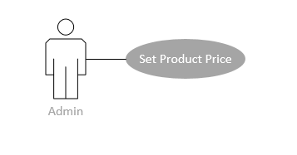

Figure 4.4 Use case for admin set product price

The following table shows the details of figure 4.4:

Table 4.8: Set Product Price Use Case Description

|  |  |  |
| --- | --- | --- |
| **Use Case ID** | UC003 | |
| **Name** | Set product price | |
| **Brief Description** | User set and changing product price in the system | |
| **Actor(s)** | Admin | |
| **Flow of Events** | | |
| **Basic Flow** | | |
| This use case starts when a system user logged into the system and goes to the stock page.   1. The system prompts the user with the list product registered in database. 2. The user select product to display. 3. System display the product. 4. User enter the value a product to set the product price. 5. System save the product. 6. Use case ends. | | |
| **Alternate Flows** | | |
| **Title** | | **Description** |
| 4a. Cancel set product | | 1. User click back button in and back to main stock page. 2. The system returns the user to stock page without save any information in database. |
| 4b. Invalid input | | 1. User click confirm after input product price to system. 2. The system display information with appropriate message to correct invalid value. 3. User re-enter value. |
| **Pre-Conditions** | | |
| **Title** | | **Description** |
| (None) | | User is not logged in. |
| **Post-Conditions** | | |
| **Title** | | **Description** |
| Success | | The new value is saved into system database and displayed |
| Failed | | The price value not save. |

### Manage Stock

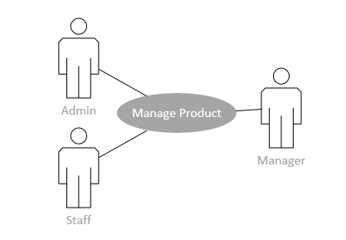

Figure 4.5 Use case for manage stock

The following table shows the details of figure 4.5:

Table 4.9: Manage Stock Use Case Description

|  |  |  |
| --- | --- | --- |
| **Use Case ID** | UC004 | |
| **Name** | Manage stock | |
| **Brief Description** | User set and changing product price in the system | |
| **Actor(s)** | Admin, Manager and staff | |
| **Flow of Events** | | |
| **Basic Flow** | | |
| This use case starts when a system user is logged into the system and goes to the stock page.   1. The system prompts the user with the list of stock in database. 2. The user selects the stock to display. 3. The system display stock information 4. The user manages the quantity gas cylinder filled and empty of stock 5. System save the value entered. 6. Use case ends. | | |
| **Alternate Flows** | | |
| **Title** | | **Description** |
| 5a. Cancel changes | | 1. User click button back and back to stock page. 2. The system returns the user to stock page without save any information in database. |
| 5b. Invalid input | | 1. User click update after quantity in stock to system. 2. The system display information with appropriate message to correct invalid value. 3. User re-enter value. |
| **Pre-Conditions** | | |
| **Title** | | **Description** |
| (None) | | User is not logged in. |
| **Post-Conditions** | | |
| **Title** | | **Description** |
| Success | | The new quantity is saved into system database and displayed |
| Failed | | The new quantity is not saved. |

### 4.3.2.5 Manage customer

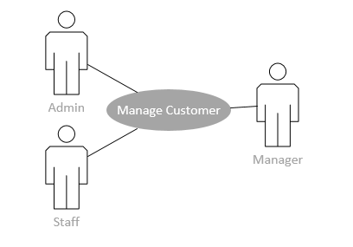

Figure 4.6 Use case for manage customer

The following table shows the details of figure 4.6:

Table 4.10: Manage Customer Use Case Description

|  |  |  |
| --- | --- | --- |
| **Use Case ID** | UC005 | |
| **Name** | Manage customer | |
| **Brief Description** | A user of the system modifies an existing record in a database. | |
| **Actor(s)** | Admin, Manager, Staff | |
| **Flow of Events** | | |
| **Basic Flow** | | |
| This use case starts when a user accesses the “manage customer”.   1. The system displays all list of customers. 2. The system display result. 3. The user selects add to add customer. 4. The user selects edit to edit information customer. 5. The user select view to view all information about customer 6. Use case ends. | | |
| **Alternate Flows** | | |
| **Title** | | **Description** |
| 4a. Cancel add customer | | 1. User click back button and back to people page. 2. The system returns the user to people page without save any information in database. |
| 4b. Invalid information input | | 1. User click save after input information of customer to system. 2. The system displays invalid information with appropriate message to correct invalid information. 3. User re-enter information and click submit. |
| **Pre-Conditions** | | |
| **Title** | | **Description** |
| (None) | | User is not logged in. |
| **Post-Conditions** | | |
| **Title** | | **Description** |
| Success | | The new customer information is saved. |
| Failed | | Customer information unsaved. |

### 4.3.2.6 Manage supplier

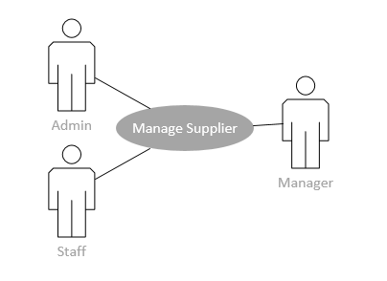

Figure 4.7 Use case for manage supplier

The following table shows the details of figure 4.7:

Table 4.11: Manage Supplier Use Case Description

|  |  |  |
| --- | --- | --- |
| **Use Case ID** | UC006 | |
| **Name** | Manage supplier | |
| **Brief Description** | A user of the system modifies an existing record in a database. | |
| **Actor(s)** | Admin, Manager, Staff | |
| **Flow of Events** | | |
| **Basic Flow** | | |
| This use case starts when a user accesses the “manage supplier”.   1. The system displays all list of suppliers. 2. The system display result. 3. The user selects add to add supplier. 4. The user selects edit to edit information supplier. 5. The user select view to view all information about supplier. 6. Use case ends. | | |
| **Alternate Flows** | | |
| **Title** | | **Description** |
| 4a. Cancel add supplier | | 1. User click back button and back to people page. 2. The system returns the user to people page without save any information in database. |
| 4b. Invalid information input | | 1. User click save after input information of supplier to system. 2. The system displays invalid information with appropriate message to correct invalid information. 3. User re-enter information and click submit. |
| **Pre-Conditions** | | |
| **Title** | | **Description** |
| (None) | | User is not logged in. |
| **Post-Conditions** | | |
| **Title** | | **Description** |
| Success | | The new supplier information is saved. |
| Failed | | Supplier information unsaved. |

### Manage Report

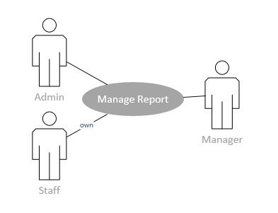

Figure 4.8 Use case for manage Report

The following table shows the details of figure 4.8:

Table 4.12: Manage Report Use Case Description

|  |  |  |
| --- | --- | --- |
| **Use Case ID** | UC007 | |
| **Name** | Manage report | |
| **Brief Description** | A user of the system modifies an existing record in a database | |
| **Actor(s)** | Admin, Manager, Staff | |
| **Flow of Events** | | |
| **Basic Flow** | | |
| This use case starts when a user accesses the “manage customer”.   1. The system displays report on information. 2. The system display stock report. 3. The system display sales report. 4. The system display summary detail report. 5. The user search for target customer. 6. The system displays all record on target customer. 7. The user search for target supplier. 8. The system displays all record on target supplier. 9. Use case ends. | | |
| **Alternate Flows** | | |
| **Title** | | **Description** |
| (None) | | (None) |
| (None) | | (None) |
| **Pre-Conditions** | | |
| **Title** | | **Description** |
| (None) | | (None) |
| **Post-Conditions** | | |
| **Title** | | **Description** |
| (None) | | (None) |
| (None) | | (None) |

### 4.3.2.8 Manage Payment

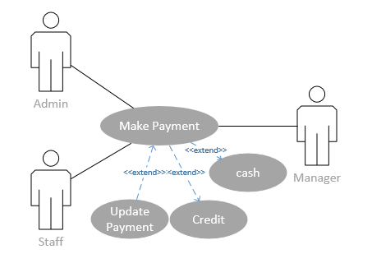

Figure 4.9 Use case for manage payment

The following table shows the details of figure 4.9:

Table 4.13: Manage Payment Use Case Description

|  |  |  |
| --- | --- | --- |
| **Use Case ID** | UC009 | |
| **Name** | Manage payment | |
| **Brief Description** | A user processes the payment for customer transaction | |
| **Actor(s)** | Admin, Manager, Staff | |
| **Flow of Events** | | |
| **Basic Flow** | | |
| This use case starts when a user accesses the “manage customer”.   1. The system prompts the user to choose payment method for current transaction. 2. The user enters payment detail. 3. User click “Save”. 4. The system calculates and save record in database. 5. Use case end. | | |
| **Alternate Flows** | | |
| **Title** | | **Description** |
| 1a. Payment method with credit | | 1. User enter payment amount provide by customer. |
| 4b. Payment method with selected cash. | | 1. User enter payment amount provide by customer. |
| **Pre-Conditions** | | |
| **Title** | | **Description** |
| (None) | | Process derive from checkout process. |
| **Post-Conditions** | | |
| **Title** | | **Description** |
| Success | | The payment record is recorded. |
| Failed | | Unable to process the transaction. |

**4.3.3 Sequence Diagram**

The sequence diagram explains more details about the Get Gas POS System for Gas Distributors Company. It used to show the interaction between specific function and actor. This diagram able to help stakeholders understand about the input and output required for each function.

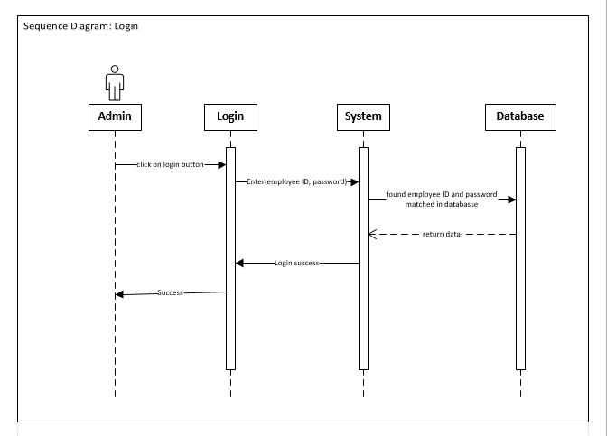

Figure 4.10 Sequence Diagram for login Get Gas POS system for Gas Distributors Company

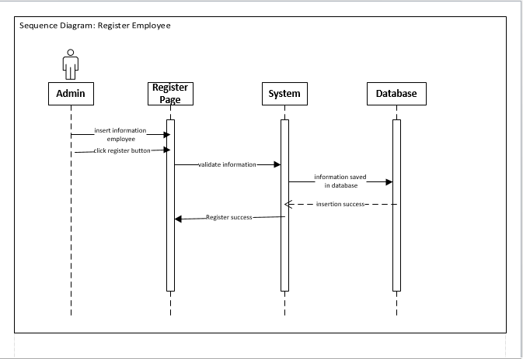

Figure 4.11 Sequence Diagram for register employee Get Gas POS system for Gas Distributors Company

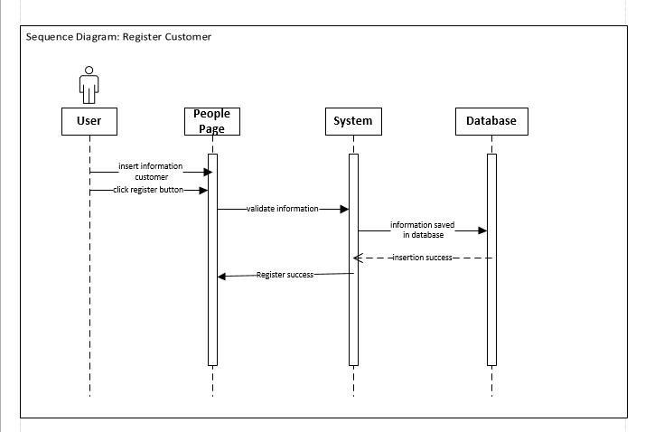

Figure 4.12 Sequence Diagram for register customer Get Gas POS system for Gas Distributors Company

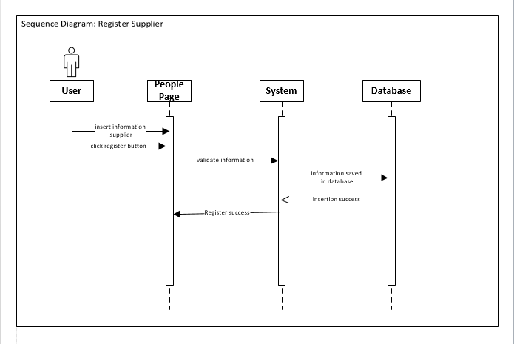

Figure 4.13 Sequence Diagram for register supplier Get Gas POS system for Gas Distributors Company

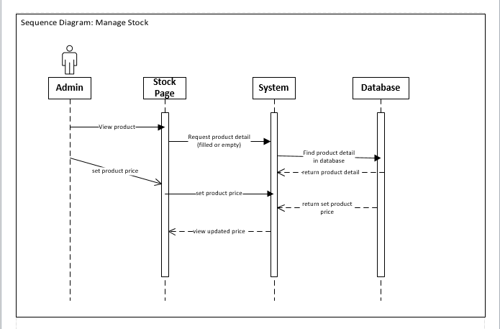

Figure 4.14 Sequence Diagram for manage stock Get Gas POS system for Gas Distributors Company

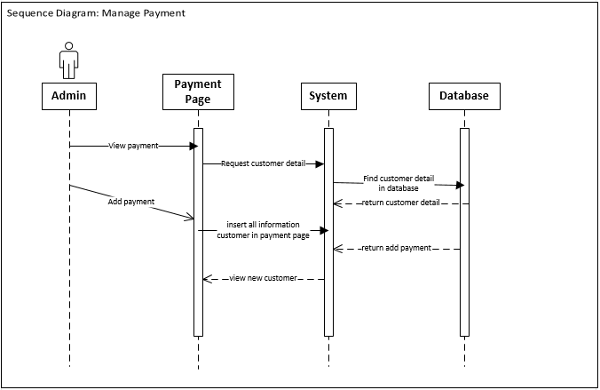

Figure 4.15 Sequence Diagram for manage payment Get Gas POS system for Gas Distributors Company

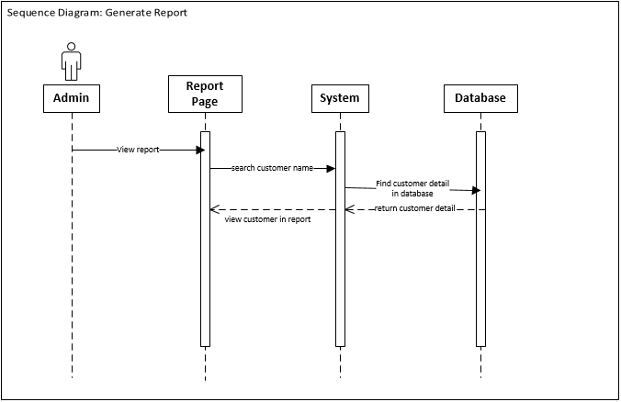

Figure 4.16 Sequence Diagram for Generate report Get Gas POS system for Gas Distributors Company

**4.3.4 Database Design**

The Get Gas POS System for Gas Distributors Company using the MySQL database. The database design illustrates in erd diagram. In the erd diagram, the data structure showing by application classes, attribute and relationship.



Figure 4.17 ERD Diagram for Get Gas POS System for Gas Distributors Company

**4.4 System Design**

**4.4.1 User Interface Design**

The interface is design based on the all requirement that involve in the system, interface for this project is web based. This interface can interact with user functionalities and relationship. The main interface for the human resource user of Get-Gas POS for Gas Distributors Company application show in Figure 4.18

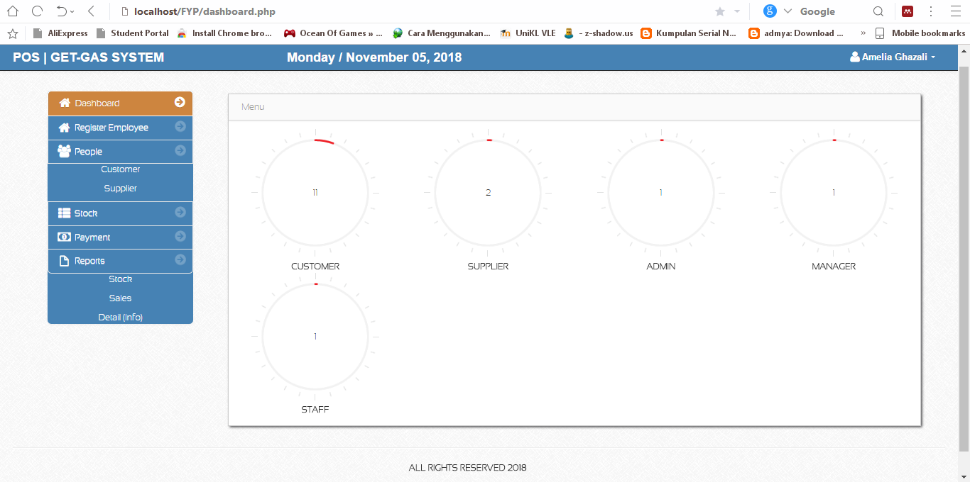

Figure 4.18 GUI for dashboard for Get Gas POS system for Gas Distributors Company

The Register employee page for the Get Gas POS system for Gas Distributors Company show in Figure 4. 19

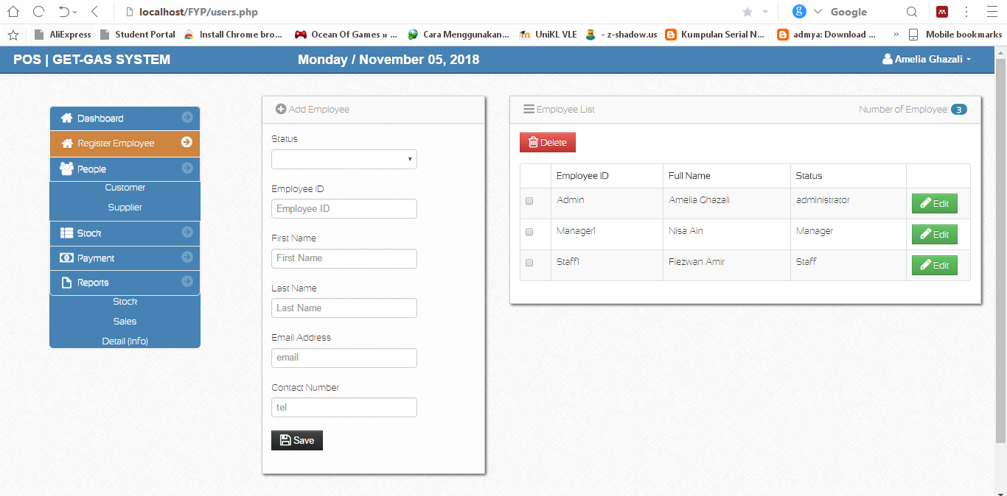

Figure 4.19 GUI for register employee for Get Gas POS system for Gas Distributors Company

The people page which is customer and supplier for the Get Gas POS system for Gas Distributors Company show in Figure 4.20 and Figure 4.21

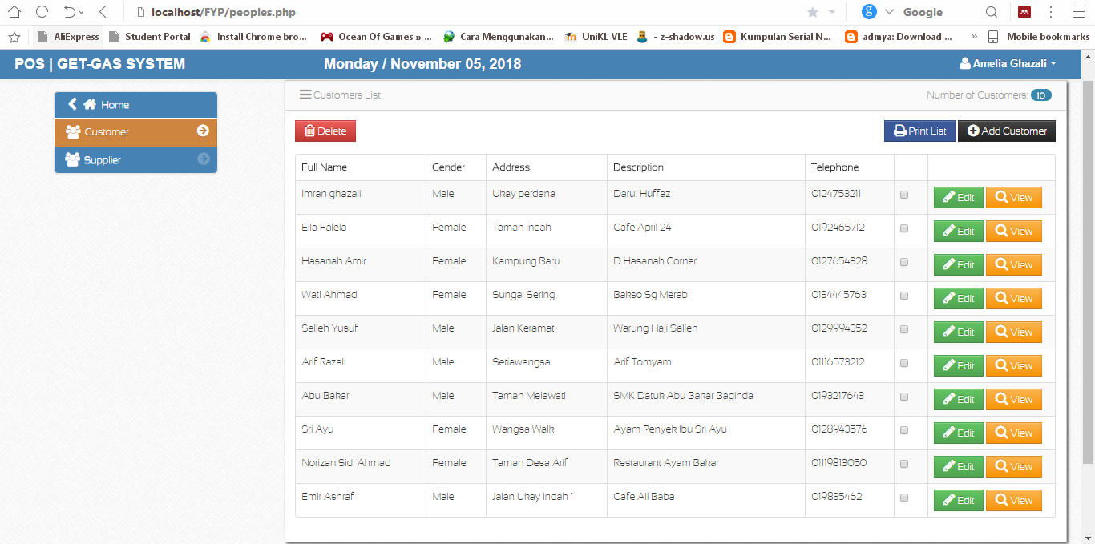

Figure 4.20 GUI for register customer for Get Gas POS system for Gas Distributors Company

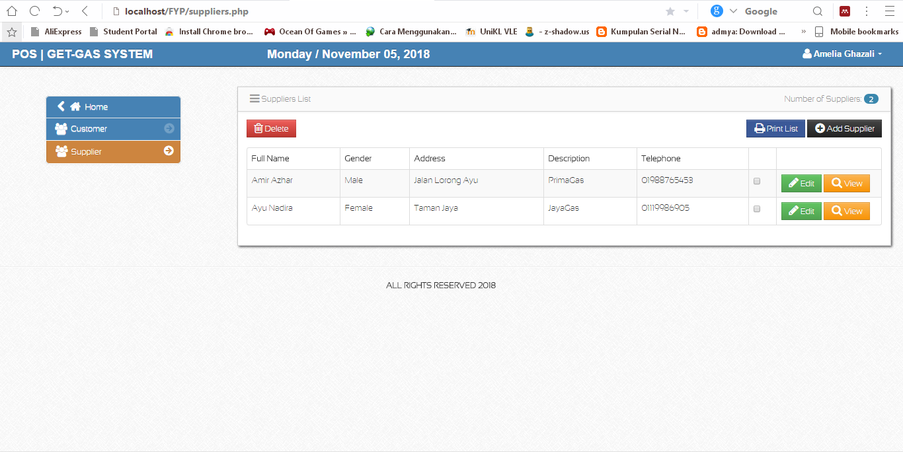

Figure 4.21 GUI for register supplier for Get Gas POS system for Gas Distributors Company

The stock page for the Get Gas POS system for Gas Distributors Company show in Figure 4. 22

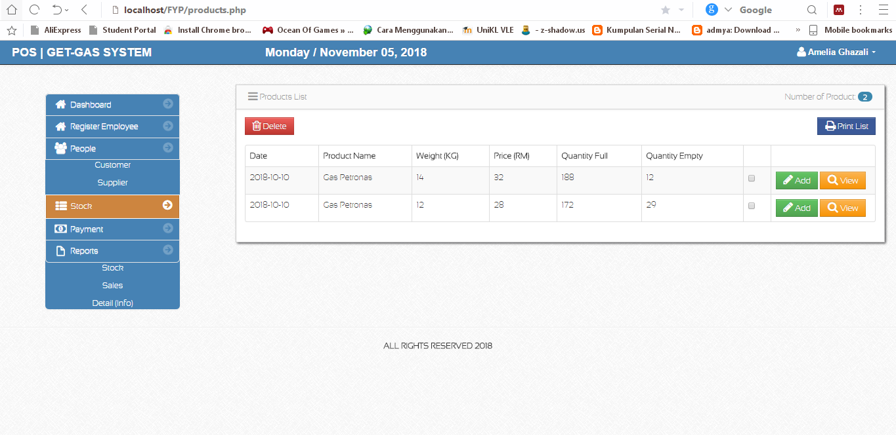

Figure 4.22 GUI for stock for Get Gas POS system for Gas Distributors Company

The payment page for the Get Gas POS system for Gas Distributors Company show in Figure 4. 23

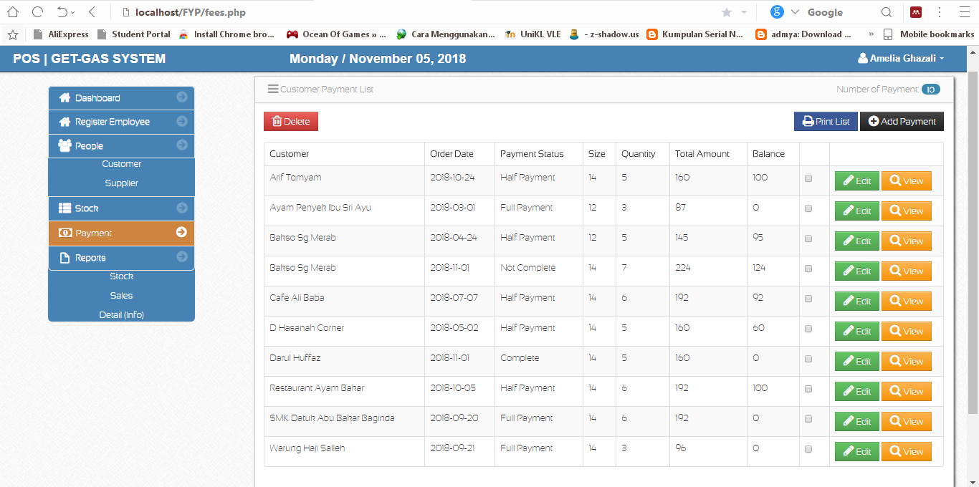

Figure 4.23 GUI for payment for Get Gas POS system for Gas Distributors Company

The stock report page for the Get Gas POS system for Gas Distributors Company show in Figure 4.24

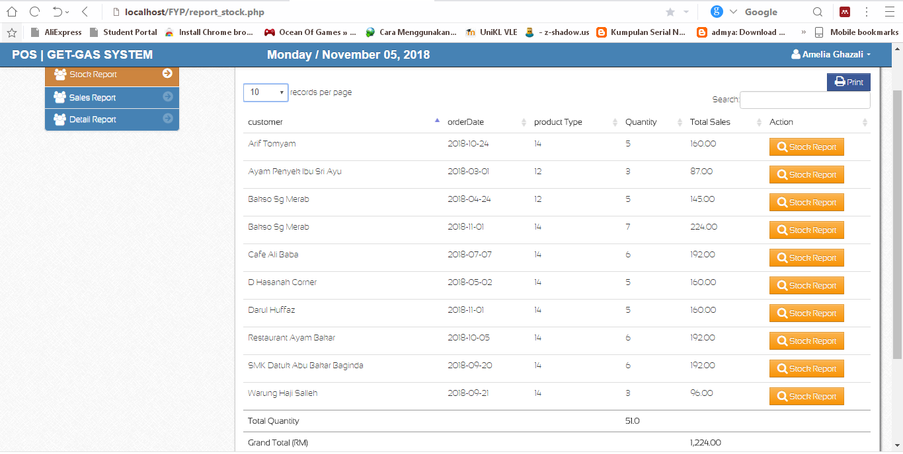

Figure 4.24 GUI for stock report for Get Gas POS system for Gas Distributors Company

The sales report page for the Get Gas POS system for Gas Distributors Company show in Figure 4.25

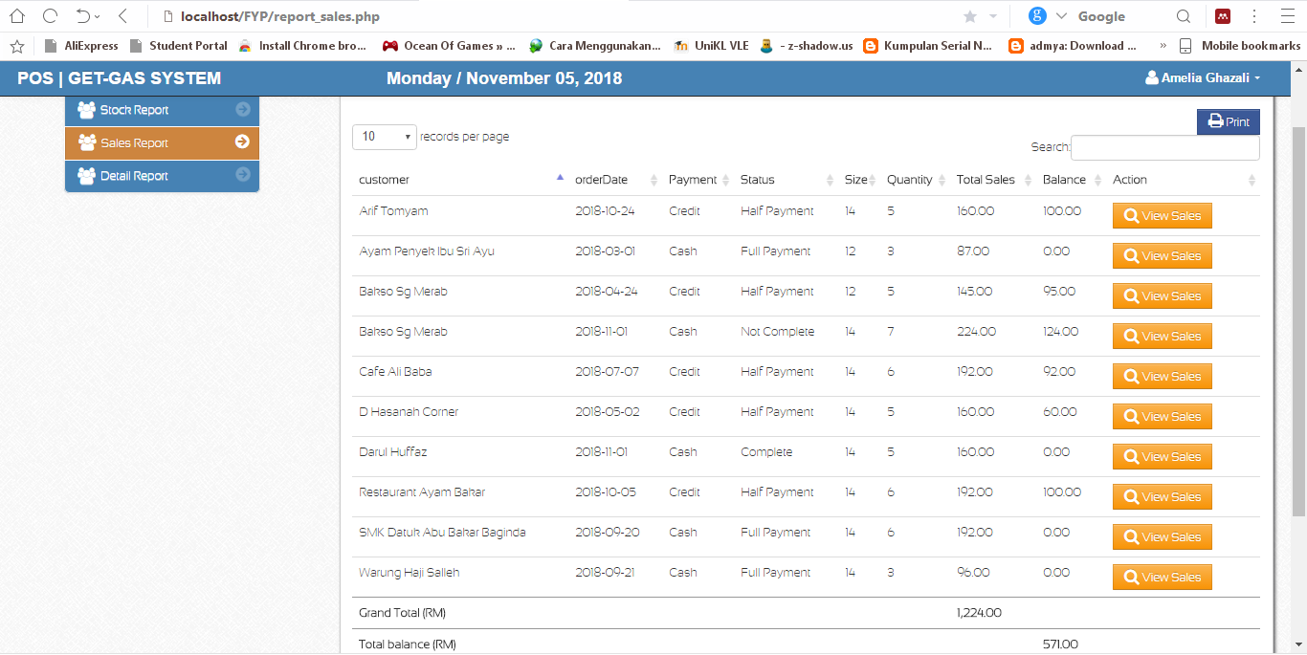

Figure 4.25 GUI for sales report for Get Gas POS system for Gas Distributors Company

The summary details report page for the Get Gas POS system for Gas Distributors Company show in Figure 4.26

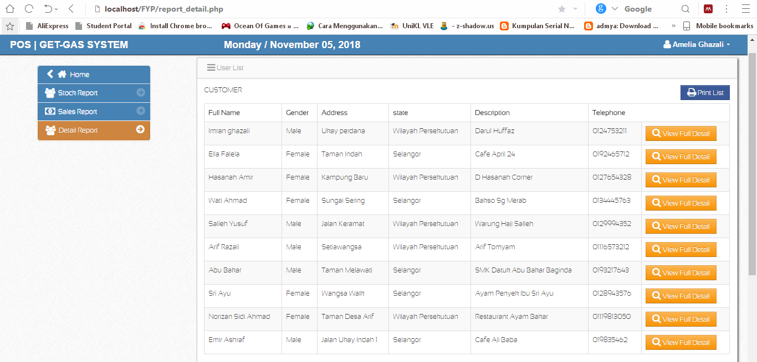

Figure 4.26 GUI for summary detail report for Get Gas POS system for Gas Distributors Company

# **CHAPTER V:**

# **TESTING AND IMPLEMENTATION**

**5.1 Introduction**

This chapter discuss the project that has been developed and recommendation for future improvement for Get Gas POS System for Gas Distributors Company. The aim of project to improve the current Get Gas POS System for Gas Distributors Company to be a better way, easily accessible and can do anywhere at any time.

**5.2 Testing Method**

Most of the developers will use different and several testing methodologies during testing stage. Fully utilization of testing level has been used by developer for this project which are as follows;

Unit testing is to determine and solve issues and errors occurs in unit or features before it implemented with other function. For this Get Gas POS System for Gas Distributors Company modules need to be tested solely to reduce or zeroized any issues and to smoothing running process.

Next is integration testing. This phase where the combination of units will be examined by several procedure. The mis-interact between unit & modules will be detected through this testing. For this project, the execution of development stage will be tested through integration testing to integrate and connect user interface with database.

Third is system testing, the functionality of overall system be tested through this testing. Comprehensive testing of integration is required before proceeds this phase.

Lastly is acceptance testing. Acceptance testing is feedback from end users on system capability is one of key elements in contributing implementation of system. For this project, users will test and check whether the output or results from this system fulfill their requirements and expectations.

**5.2.1 Test Cases**

This template of test case will be used as a requirement in conducting all testing types. This is for recording as in case if bugs are found in the project. Following is the sample of test case template:

|  |  |  |  |
| --- | --- | --- | --- |
| **Tested By:** | |  | |
| **Test Type** | |  | |
| **Test Case Number** | |  | |
| **Test Case Name** | |  | |
| **Test Case Description** | |  | |
| **Item(s) to be tested** | | | |
| 1 |  | | |
| 2 |  | | |
| **Specifications** | | | |
| **Input** | | | **Expected**  **Output/Result** |
|  | | |  |
| **Procedural Steps** | | | |
| 1 |  | | |
| 2 |  | | |
| 3 |  | | |
| 4 |  | | |
| 5 |  | | |
| 6 |  | | |

Figure 5.1: Test Case Template

5.2.2 Features to be Tested

Table 5.1: Feature to be tested table

|  |  |  |
| --- | --- | --- |
| **Function ID** | **Functions** | **Risk Level** |
| FOO1 | Login for Web Application () | High |
| FOO2 | Register Employee () | High |
| FOO3 | Manage Employee Information () | High |
| FOO4 | Register Customer () | High |
| FOO5 | Manage Customer Information () | High |
| FOO6 | Register Supplier () | High |
| FOO7 | Manage Supplier Information () | High |
| FOO8 | Manage Stock () | High |
| FO09 | Manage Payment () | High |
| FO10 | Generate Stock Report () | High |
| FO11 | Generate Sales Report () | High |
| FO12 | Generate Summary Details Report () | High |
| FO13 | Logout for Web Application () | High |

|  |  |  |  |
| --- | --- | --- | --- |
| **Tested By:** | | Noramelia Binti Che Ghazali | |
| **Test Case Number** | | TC_POS_001 | |
| **Function ID:** | | F001 | |
| **Test Case Name** | | Login for Web Application () | |
| **Test Case Description** | | User need to enter employee ID and correct password before using this system | |
| **Item(s) to be tested** | | | |
| 1 | Employee ID | | |
| 2 | Password | | |
| **Specifications** | | | |
| **Input** | | | **Expected**  **Output/Result** |
| Valid employee ID and password | | | System display dashboard page. |
| **Procedural Steps** | | | |
| 1 | Enter valid Employee ID | | |
| 2 | Enter valid password | | |
| 3 | Click “Sign in” button | | |
| 4 | Wait system credential | | |
| 5 | System display main dashboard page | | |

Figure 5.2: Test Case 1

|  |  |  |  |
| --- | --- | --- | --- |
| **Tested By:** | | Noramelia Binti Che Ghazali | |
| **Test Case Number** | | TC_POS_002 | |
| **Function ID:** | | F002 | |
| **Test Case Name** | | Register Employee () | |
| **Test Case Description** | | User (admin) need to register new employee before use this system. They can get their own employee ID to access with their own roles. | |
| **Item(s) to be tested** | | | |
| 1 | Status | | |
| 2 | Employee ID | | |
| 3 | First Name | | |
| 4 | Last Name | | |
| 5 | Email Address | | |
| 6 | Contact Number | | |
| **Specifications** | | | |
| **Input** | | | **Expected**  **Output/Result** |
| Valid status, employee ID, first name, last name, email address and contact number | | | System display register page. |
| **Procedural Steps** | | | |
| 1 | Choose status for employee | | |
| 2 | Enter valid employee ID | | |
| 3 | Enter valid first name | | |
| 4 | Enter valid last name | | |
| 5 | Enter valid email Address | | |
| 6 | Enter valid contact number | | |
| 7 | Click “Register” button | | |
| 8 | Wait system credential | | |
| 9 | New employee registered | | |
| 10 | System display register page | | |

Figure 5.3: Test Case 2

|  |  |  |  |
| --- | --- | --- | --- |
| **Tested By:** | | Noramelia Binti Che Ghazali | |
| **Test Case Number** | | TC_POS_003 | |
| **Function ID:** | | F003 | |
| **Test Case Name** | | Manage Employee Information () | |
| **Test Case Description** | | User updating a customer information | |
| **Item(s) to be tested** | | | |
| 1 | Input field for employee information | | |
| **Specifications** | | | |
| **Input** | | | **Expected**  **Output/Result** |
| Valid employee information (Status, Employee ID, First Name, Last Name, Email Address, Contact Number) | | | Updated employee information in database system. |
| **Procedural Steps** | | | |
| 1 | Select employee | | |
| 2 | Display employee information | | |
| 3 | Click edit button | | |
| 4 | User change employee information | | |
| 5 | Wait system to verify the information | | |
| 6 | New employee information is updated in database system | | |

Figure 5.4: Test Case 3

|  |  |  |  |
| --- | --- | --- | --- |
| **Tested By:** | | Noramelia Binti Che Ghazali | |
| **Test Case Number** | | TC_POS_003 | |
| **Function ID:** | | F003 | |
| **Test Case Name** | | Manage Employee Information () | |
| **Test Case Description** | | Admin delete an employee information | |
| **Item(s) to be tested** | | | |
| 1 | Delete employee information | | |
| **Specifications** | | | |
| **Input** | | | **Expected**  **Output/Result** |
| Delete employee information (Status, Employee ID, First Name, Last Name, Email Address, Contact Number) | | | employee information in database system are deleted. |
| **Procedural Steps** | | | |
| 1 | Select employee | | |
| 2 | Display employee information | | |
| 3 | Admin delete employee information | | |
| 3 | Wait system to verify the information | | |
| 4 | employee information in database system are deleted. | | |

Figure 5.5: Test Case 3

|  |  |  |  |
| --- | --- | --- | --- |
| **Tested By:** | | Noramelia Binti Che Ghazali | |
| **Test Case Number** | | TC_POS_004 | |
| **Function ID:** | | F004 | |
| **Test Case Name** | | Register Customer () | |
| **Test Case Description** | | User need to register new customer in to system. | |
| **Item(s) to be tested** | | | |
| 1 | Input field for customer information | | |
| 2 | Save button | | |
| **Specifications** | | | |
| **Input** | | | **Expected**  **Output/Result** |
| Valid customer information (Status, First Name, Last Name, Gender, Date of Birth, Address, Email, State, Description, Contact Number, IC Number) | | | New customer is registered in the system |
| **Procedural Steps** | | | |
| 1 | Enter valid information | | |
| 2 | Click “Save” button | | |
| 3 | System prompts user with registered form | | |
| 3 | Wait system credential | | |
| 4 | New customer is registered in the system | | |

Figure 5.6: Test Case 4

|  |  |  |  |
| --- | --- | --- | --- |
| **Tested By:** | | Noramelia Binti Che Ghazali | |
| **Test Case Number** | | TC_POS_005 | |
| **Function ID:** | | F005 | |
| **Test Case Name** | | Manage Customer information () | |
| **Test Case Description** | | User updating a customer information | |
| **Item(s) to be tested** | | | |
| 1 | Input field for customer information | | |
| **Specifications** | | | |
| **Input** | | | **Expected**  **Output/Result** |
| Valid customer information (Status, First Name, Last Name, Gender, Date of Birth, Address, Email, State, Description, Contact Number, IC Number) | | | Updated customer information in database system. |
| **Procedural Steps** | | | |
| 1 | Select customer | | |
| 2 | Display customer information | | |
| 3 | Click edit button | | |
| 4 | User change customer information | | |
| 5 | Wait system to verify the information | | |
| 6 | New customer information is updated in database system | | |

Figure 5.7: Test Case 5

|  |  |  |  |
| --- | --- | --- | --- |
| **Tested By:** | | Noramelia Binti Che Ghazali | |
| **Test Case Number** | | TC_POS_005 | |
| **Function ID:** | | F005 | |
| **Test Case Name** | | Manage Customer information () | |
| **Test Case Description** | | Admin delete a customer information | |
| **Item(s) to be tested** | | | |
| 1 | Delete customer information | | |
| **Specifications** | | | |
| **Input** | | | **Expected**  **Output/Result** |
| Valid customer information (Status, First Name, Last Name, Gender, Date of Birth, Address, Email, State, Description, Contact Number, IC Number) | | | customer information in database system are deleted. |
| **Procedural Steps** | | | |
| 1 | Select customer | | |
| 2 | Display customer information | | |
| 3 | Admin delete customer information | | |
| 3 | Wait system to verify the information | | |
| 4 | Customer information in database system are deleted. | | |

Figure 5.8: Test Case 5

|  |  |  |  |
| --- | --- | --- | --- |
| **Tested By:** | | Noramelia Binti Che Ghazali | |
| **Test Case Number** | | TC_POS_006 | |
| **Function ID:** | | F006 | |
| **Test Case Name** | | Register Supplier () | |
| **Test Case Description** | | User need to register new supplier in to system. | |
| **Item(s) to be tested** | | | |
| 1 | Input field for supplier information | | |
| 2 | Save button | | |
| **Specifications** | | | |
| **Input** | | | **Expected**  **Output/Result** |
| Valid supplier information (Status, First Name, Last Name, Gender, Date of Birth, Address, Email, State, Description, Contact Number, IC Number) | | | New supplier is registered in the system |
| **Procedural Steps** | | | |
| 1 | Enter valid information | | |
| 2 | Click “Save” button | | |
| 3 | System prompts user with registered form | | |
| 3 | Wait system credential | | |
| 4 | New supplier is registered in the system | | |

Figure 5.9: Test Case 6

|  |  |  |  |
| --- | --- | --- | --- |
| **Tested By:** | | Noramelia Binti Che Ghazali | |
| **Test Case Number** | | TC_POS_007 | |
| **Function ID:** | | F007 | |
| **Test Case Name** | | Manage Supplier information () | |
| **Test Case Description** | | Admin delete a supplier information | |
| **Item(s) to be tested** | | | |
| 1 | Delete supplier information | | |
| **Specifications** | | | |
| **Input** | | | **Expected**  **Output/Result** |
| Valid supplier information (Status, First Name, Last Name, Gender, Date of Birth, Address, Email, State, Description, Contact Number, IC Number) | | | supplier information in database system are deleted. |
| **Procedural Steps** | | | |
| 1 | Select supplier | | |
| 2 | Display supplier information | | |
| 3 | Admin delete supplier information | | |
| 3 | Wait system to verify the information | | |
| 4 | Supplier information in database system are deleted. | | |

Figure 5.10: Test Case 7

|  |  |  |  |
| --- | --- | --- | --- |
| **Tested By:** | | Noramelia Binti Che Ghazali | |
| **Test Case Number** | | TC_POS_007 | |
| **Function ID:** | | F007 | |
| **Test Case Name** | | Manage supplier information () | |
| **Test Case Description** | | User updating a supplier information | |
| **Item(s) to be tested** | | | |
| 1 | Input field for supplier information | | |
| **Specifications** | | | |
| **Input** | | | **Expected**  **Output/Result** |
| Valid supplier information (Status, First Name, Last Name, Gender, Date of Birth, Address, Email, State, Description, Contact Number, IC Number) | | | Updated supplier information in database system. |
| **Procedural Steps** | | | |
| 1 | Select supplier | | |
| 2 | Display supplier information | | |
| 3 | Click edit button | | |
| 4 | User change supplier information | | |
| 5 | Wait system to verify the information | | |
| 6 | New supplier information is updated in database system | | |

Figure 5.11: Test Case 7

|  |  |  |  |
| --- | --- | --- | --- |
| **Tested By:** | | Noramelia Binti Che Ghazali | |
| **Test Case Number** | | TC_POS_008 | |
| **Function ID:** | | F008 | |
| **Test Case Name** | | Manage Stock () | |
| **Test Case Description** | | Admin updating product information in the stock page | |
| **Item(s) to be tested** | | | |
| 1 | Input field for empty gas cylinder value | | |
| 2 | Input field for filled gas cylinder value | | |
| **Specifications** | | | |
| **Input** | | | **Expected**  **Output/Result** |
| Valid value of empty and filled gas cylinder | | | Updated product stock information is saved in the system database |
| **Procedural Steps** | | | |
| 1 | Select product | | |
| 2 | Wait system to display information of the product | | |
| 3 | User change the quantity value of the product | | |
| 3 | Wait system to verify the value | | |
| 4 | Product stock information is saved in the system database | | |

Figure 5.12: Test Case 8

|  |  |  |  |
| --- | --- | --- | --- |
| **Tested By:** | | Noramelia Binti Che Ghazali | |
| **Test Case Number** | | TC_POS_008 | |
| **Function ID:** | | F008 | |
| **Test Case Name** | | Manage Stock () | |
| **Test Case Description** | | Admin delete product information in the stock page | |
| **Item(s) to be tested** | | | |
| 1 | Input field for empty gas cylinder value | | |
| 2 | Input field for filled gas cylinder value | | |
| **Specifications** | | | |
| **Input** | | | **Expected**  **Output/Result** |
| Delete value of empty and filled gas cylinder | | | Updated product stock information is saved in the system database |
| **Procedural Steps** | | | |
| 1 | Select product | | |
| 2 | Wait system to display information of the product | | |
| 3 | User (admin) delete the quantity value of the product | | |
| 3 | Wait system to verify the value | | |
| 4 | Deleted product stock information is saved in the system database | | |

Figure 5.13: Test Case 8

|  |  |  |  |
| --- | --- | --- | --- |
| **Tested By:** | | Noramelia Binti Che Ghazali | |
| **Test Case Number** | | TC_POS_009 | |
| **Function ID:** | | F009 | |
| **Test Case Name** | | Manage Payment () | |
| **Test Case Description** | | User manage the purchase process of registered customer | |
| **Item(s) to be tested** | | | |
| 1 | Product list | | |
| 2 | Input field for product quantity | | |
| 3 | Input field for customer | | |
| **Specifications** | | | |
| **Input** | | | **Expected**  **Output/Result** |
| Valid register customer | | | System display list of customers with their sales report |
| **Procedural Steps** | | | |
| 1 | User go to payment page | | |
| 2 | Click “add payment” | | |
| 3 | User choose customer | | |
| 4 | User choose order date | | |
| 5 | User choose payment type (Cash or Credit) | | |
| 6 | User choose payment status (Complete or Not Complete) | | |
| 7 | User choose product type | | |
| 8 | Enter the price | | |
| 9 | Set quantity buy | | |
| 10 | Set quantity received | | |
| 11 | Enter Paid Amount | | |
| 12 | Click “save” | | |
| 13 | System display list of customers with their sales report | | |

Figure 5.14: Test Case 9

|  |  |  |  |
| --- | --- | --- | --- |
| **Tested By:** | | Noramelia Binti Che Ghazali | |
| **Test Case Number** | | TC_POS_010 | |
| **Function ID:** | | F010 | |
| **Test Case Name** | | Generate Stock Report () | |
| **Test Case Description** | | User generate stock report | |
| **Item(s) to be tested** | | | |
| 1 | Report selection | | |
| 2 | Report content | | |
| **Specifications** | | | |
| **Input** | | | **Expected**  **Output/Result** |
| Date | | | System display stock report |
| **Procedural Steps** | | | |
| 1 | User login | | |
| 2 | Wait system authentication | | |
| 3 | Click report | | |
| 4 | User select for stock report | | |
| 5 | User set report date | | |
| 6 | Wait system to generate report | | |
| 7 | Product display stock report | | |

Figure 5.15: Test Case 10

|  |  |  |  |
| --- | --- | --- | --- |
| **Tested By:** | | Noramelia Binti Che Ghazali | |
| **Test Case Number** | | TC_POS_011 | |
| **Function ID:** | | F011 | |
| **Test Case Name** | | Generate Sales Report () | |
| **Test Case Description** | | User generate sales report | |
| **Item(s) to be tested** | | | |
| 1 | Report selection | | |
| 2 | Report content | | |
| **Specifications** | | | |
| **Input** | | | **Expected**  **Output/Result** |
| Date | | | System display sales report |
| **Procedural Steps** | | | |
| 1 | User login | | |
| 2 | Wait system authentication | | |
| 3 | Click report | | |
| 4 | User select for sales report | | |
| 5 | User set report date | | |
| 6 | Wait system to generate report | | |
| 7 | Product display sales report | | |

Figure 5.16: Test Case 11

|  |  |  |  |
| --- | --- | --- | --- |
| **Tested By:** | | Noramelia Binti Che Ghazali | |
| **Test Case Number** | | TC_POS_012 | |
| **Function ID:** | | F012 | |
| **Test Case Name** | | Generate Summary Details Report () | |
| **Test Case Description** | | User generate summary details report | |
| **Item(s) to be tested** | | | |
| 1 | Report selection | | |
| 2 | Report content | | |
| **Specifications** | | | |
| **Input** | | | **Expected**  **Output/Result** |
| Date | | | System display detail (info) report |
| **Procedural Steps** | | | |
| 1 | User login | | |
| 2 | Wait system authentication | | |
| 3 | Click report | | |
| 4 | User select for detail (info) report | | |
| 5 | User set report date | | |
| 6 | Wait system to generate report | | |
| 7 | Product display detail (info) report | | |

Figure 5.17: Test Case 12

|  |  |  |  |
| --- | --- | --- | --- |
| **Tested By:** | | Noramelia Binti Che Ghazali | |
| **Test Case Number** | | TC_POS_013 | |
| **Function ID:** | | F013 | |
| **Test Case Name** | | Logout for Web Application () | |
| **Test Case Description** | | User click logout button | |
| **Item(s) to be tested** | | | |
| 1 | - | | |
| 2 | - | | |
| **Specifications** | | | |
| **Input** | | | **Expected**  **Output/Result** |
| - | | | System display login page. |
| **Procedural Steps** | | | |
| 1 | Click button logout | | |
| 2 | Wait system credential | | |
| 3 | System display main login page | | |

Figure 5.18: Test Case 13

**5.3 User Acceptance Testing**

User acceptance testing should be done as a final testing for the user to test and know either this application can be accepted and be usable by other users. Result are available below:

**5.4 Open Evaluation Analysis**

A total of 30 evaluation forms have been distributed to UniKL MIIT students during the presentation day of Final Year Project 2 to get the user’s feedback on the Get Gas POS System for Gas Distributors Company. The results from the evaluation form will change into graph.

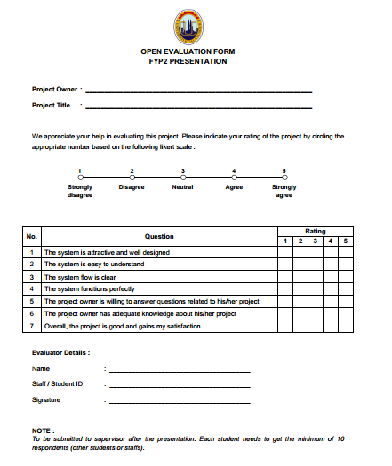

Figure 5.19 Example of Evaluation Form

5.4.1 Question 1: The system is attractive and well designed

|  |  |
| --- | --- |
| **Response** | **Number of Respondents** |
| Strongly Disagree | 0 |
| Disagree | 0 |
| Neutral | 0 |
| Agree | 5 |
| Strongly Agree | 25 |

Table 5.2 Question 1 table

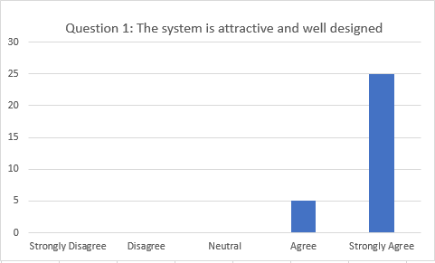

Figure 5.20 Question 1 Graph

5.4.2 Question 2: The system is easy to understand

|  |  |
| --- | --- |
| **Response** | **Number of Respondents** |
| Strongly Disagree | 0 |
| Disagree | 0 |
| Neutral | 0 |
| Agree | 4 |
| Strongly Agree | 27 |

Table 5.3 Question 2 table

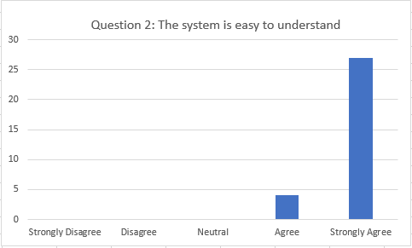

Figure 5.21 Question 2 Graph

5.4.3 Question 3: The system flow is clear

|  |  |
| --- | --- |
| **Response** | **Number of Respondents** |
| Strongly Disagree | 0 |
| Disagree | 0 |
| Neutral | 0 |
| Agree | 5 |
| Strongly Agree | 25 |

Table 5.4 Question 3 table

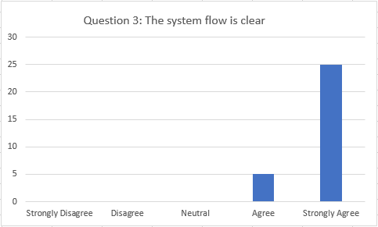

Figure 5.22 Question 3 Graph

5.4.4 Question 4: The system functions perfectly

|  |  |
| --- | --- |
| **Response** | **Number of Respondents** |
| Strongly Disagree | 0 |
| Disagree | 0 |
| Neutral | 0 |
| Agree | 2 |
| Strongly Agree | 28 |

Table 5.5 Question 4 table

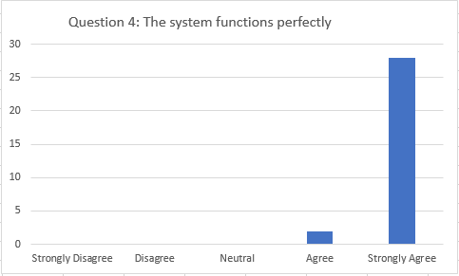

Figure 5.23 Question 4 Graph

5.4.5 Question 5: The project owner is willing to answer questions related to his/her project

|  |  |
| --- | --- |
| **Response** | **Number of Respondents** |
| Strongly Disagree | 0 |
| Disagree | 0 |
| Neutral | 0 |
| Agree | 2 |
| Strongly Agree | 28 |

Table 5.6 Question 5 table

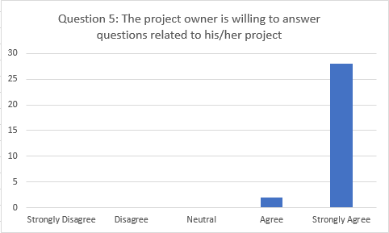

Figure 5.24 Question 5 Graph

5.4.6 Question 6: The project owner has adequate knowledge about his/her project

|  |  |
| --- | --- |
| **Response** | **Number of Respondents** |
| Strongly Disagree | 0 |
| Disagree | 0 |
| Neutral | 0 |
| Agree | 2 |
| Strongly Agree | 28 |

Table 5.7 Question 6 table

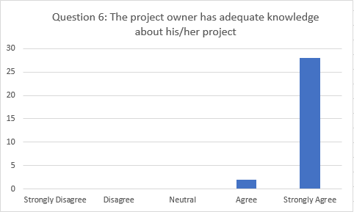

Figure 5.25 Question 6 Graph

5.4.7 Question 7: The project owner has adequate knowledge about his/her project

|  |  |
| --- | --- |
| **Response** | **Number of Respondents** |
| Strongly Disagree | 0 |
| Disagree | 0 |
| Neutral | 0 |
| Agree | 1 |
| Strongly Agree | 29 |

Table 5.8 Question 7 table

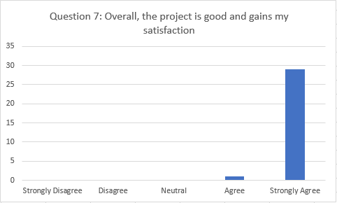

Figure 5.26 Question 7 Graph

**5.5 Implementation**

* Gas Distributors Company only can use this system.
* It is available only for Retail Company.

# **CHAPTER IV:**

# **CONCLUSION AND RECOMMENDATION**

**6.1 Conclusion of the project**

The conclusion for this Get Gas POS System for Gas Distributors company it will benefit to all Gas Distributors Company. This project is developed web-based system to help them manage their product and easy to use. We know that, retail company just used manual for every part such as they just keep their report in paper, so this system can help them to keep their report in save place.

**6.2 Review of objectives**

The objectives of the system:

1. To design and build comprehensive Point of Sale (POS) system for Gas Distributor Company (Retail SME).

* This project will able to design and to develop a web-based system to Gas Distributors Company.

1. To record and track client’s sales and buyer information.

* This project will able to record the information buyer and keep the information in system.

1. To automate cost calculation and produce stock report, sales report, summary detail report

* This project will able the automate calculation in payment to reduce human error and keep the final cost.

**6.3 Advantages and Disadvantages**

|  |  |
| --- | --- |
| **Advantages** | **Disadvantages** |
| * Can help retail company to keep report for them. | * Only can be used for Gas Distributors Company |
| * Easy to handle the stock in and out for gas cylinder. | * Only support web based |
| * To get the right final cost without used human calculation. |  |

Table 6.1 Advantages and disadvantage

* 1. **Limitation of the system**

1. Only support web based
2. Only can be used for Gas Distributors Company
3. Just one type of product provides in this system which is Gas Petronas

**6.5 Recommendations**

This project is just to Gas Distributors Company to improve their current stock management system. The web application project should be improved by adding several function and innovation to make it a competitive and attractive product suitable for industry used.

Therefore, the future recommendation of this project:

1. Make it available for mobile application Android and IOS

* This project only used in web application. To be more friendly system and more suitable for industry used, every system needs a mobile application to easy for user use.

1. Make the module report more flexible.

* In the sales report module, the user needs to click one by one customer to view their report sales. It can be problem to user to generate the full sales report by date.

1. Notifications alert when stock quantity less than 50

* The web application does not provide the pop-up notification. Sometimes the user does not alert about the stock that already updated or not.

# **REFERENCES**

1 Adolph, M. (2012). Mobile Application. *Wired (July)*, 1-5.

2. Bryner, J. (2012). Interested in learning SANS Institude InfoSec Reading Room. *Information Security*, 18.

3. Ezysoftsolution. (2018, 23 January). Hawker POS (Point Of Sales) (version 1.16) [Mobile application software] Retrieved from http://googlePlayStore.com

4. Ibrahim Khalil, M. (2017, Jun 20). ShopKeep(POS | Shop Transaction Register | Monitor) (version 2.6) [Mobile application software] Retrieved from http://googleAppStore.com

5. Infusion121. (2017, April 30). Retail App (version 1.16.0.0) [Mobile application software] Retrieved from http://googlePlayStore.com.

*6. Retail Pro Software Solutions | Your global retail software partner*. (2017). Retrieved from Retail Pro International: http://retailpro.com/

7. TheAppSolution. (2018). *Why is a Mobile App Useful for Retail Business?* Retrieved from The App Solutions: https://theappsolutions.com/blog/development/app-for-retail/

*8. Vend - Point of sale you'll love to use.* (2014). Retrieved from Vend HQ: https://www.vendhq.com/

9. Gas cylinder Meaning in Wikipedia. Retrieved from https://en.wikipedia.org/wiki/Gas_cylinder

10. Mobile operating system market share in Malaysia 2016. (n.d.). Retrieved from http://gs.statcounter.com/os-market-share/mobile/malaysia/2016

11. Henderson, N. C.; Berry, W. E.; Eibar, R. J.; Frink, D. W. (1970). "Investigation of scuba cylinder corrosion, Phase 1". National Underwater Accident Data Center Technical Report Number 1. University of Rhode Island. Retrieved 2016-01-11. http://archive.rubicon-foundation.org/xmlui/handle/123456789/9293

12. Gas distributor company. Retrieved from https://www.ranker.com/list/natural-gas-distribution-companies/reference

13. Quick, P.S. (September 30, 2015). All About: Mighty Middle Chinese Dynasties. AUK Academic.

**APPENDIX A : SOFTWARE REQUIREMENTS SPECIFICATION (SRS)**

**APPENDIX B : Software Test Plan (STP)**

**APPENDIX C : GANTT CHART**

**APPENDIX D : USE CASE DIAGRAM**

**APPENDIX E : ERD DIAGRAM**

**APPENDIX F : CODING (SELECTED FUNCTION)**

**APPENDIX G : USER MANUAL**